UNIGLOBE COLLEGE

**(Affiliated to Pokhara University)**

New Baneswor, Kathmandu



**Third Semester Project Report**

**on**

**“AnonAeon: Anonymous Feedback Wall”**

**(CMP273)**

A Third Semester Project Report submitted in the partial fulfillment of the requirements for the degree of Bachelor of Computer System and Information Technology awarded by Pokhara University

**Under the supervision of**

**Bipin Maharjan**

**Lecturer/Supervisor**

**Submitted By:**

**Shulabh Shrestha (P.U. Registration No. 2024-2-08-0747)**

**Submitted To:**

**UNIGLOBE COLLEGE**

**Department of Computer Science and Information Technology**

**New Baneswor, Kathmandu, Nepal**

**November, 2025**

**“AnonAeon: Anonymous Feedback Wall”**

**(CMP273)**

A third semester project report submitted in partial fulfillment of the requirements for the degree of Bachelor of Computer System and Information Technology awarded by Pokhara University

**Submitted By**

Shulabh Shrestha (P.U. Registration No. 2024-2-08-0747)

**Submitted To**

**UNIGLOBE COLLEGE**

**Department of Computer Science and Information Technology**

**New Baneshwor, Kathmandu, Nepal**

**November, 2025**

# TABLE OF CONTENTS

Table of Contents

TABLE OF CONTENTS 3

ABBREVIATIONS 4

CHAPTER 1: INTRODUCTION 1

1.1 Background 1

1.2 Problem Statement 1

1.3 Objectives of the Project 1

1.4 Scope of the Project 1

1.5 Limitations of the Project 2

1.6 Significance of the Study 2

CHAPTER 2: LITERATURE REVIEW 3

CHAPTER 3: SYSTEM ANALYSIS AND DESIGN 4

3.1 Project Management Strategy and Development Tools 4

3.1.1 Project Team 4

3.1.2 Project Flow and Schedule 4

3.1.3 Responsibilities 5

3.1.4 Development Tools 6

3.2 System Analysis 7

3.2.1 Requirement Analysis 7

3.2.2 Feasibility Analysis 8

3.3 System Design 9

3.3.1. System Flowchart 9

3.3.2 Workflow 10

3.3.3 Data Flow Diagram 11

3.3.4 ER Diagram 12

3.3.5 Use Case Diagram 13

3.3.6 Schema of Database 13

3.3.7 Sequence diagrams 14

CHAPTER 4: SYSTEM IMPLEMENTATION 16

4.1 Project Schedule 16

4.1.1 Detailed Time Schedule 17

4.1.2 Detailed Gantt Chart 17

CHAPTER 5: CONCLUSION AND FUTURE ENHANCEMENT 23

5.1 Conclusion 23

5.2 Future Enhancement 23

REFERENCES 24

# ABBREVIATIONS

|  |  |
| --- | --- |
| CSS  HTML  JS  SQL  PHP  XAMPP | Cascading Style Sheet  Hyper Text Markup Language  JavaScript  Sequence Query Language  Hypertext Preprocessor  Cross-Platform (X), Apache (A), MariaDB (M), PHP (P), and Perl (P) |
|  |  |
|  |  |
|  |  |
|  |  |

# CHAPTER 1: INTRODUCTION

## Background

## Feedback mechanisms are essential tools for driving improvement and fostering engagement in both professional and educational settings. While traditional methods like standardized forms and annual surveys provide formal metrics, they often lack the immediacy and candor required for effective, continuous quality improvement [1, 2]. The integration of real-time, anonymous feedback systems has emerged as a promising strategy to overcome these limitations, providing a direct channel for stakeholders to communicate their experiences and concerns without fear of negative repercussions [1]. This approach is increasingly vital in high-stakes environments such as medical education and clinical healthcare settings.

References

[1] Shaheen, A., Azam, F., & Irshad, K. (2021). Anonymous Feedback: A Real-time Feedback to Capture Students' Engagement in Learning Process. Proceedings of the International Conference on Medical Education (ICME 2021), 65–68.

[2] Frampton, A., Fox, F., Hollowood, A., et al. (2017). Using real-time, anonymous staff feedback to improve staff experience and engagement. BMJ Quality Improvement Reports, 6(1).

### 1.2 Problem Statement

Traditional, non-anonymous feedback systems often fail to capture honest and detailed qualitative data due to the inherent reluctance and fear of identification among students and staff [1]. This gap limits the ability of institutions to quickly identify and act upon factors that critically impact staff satisfaction, student engagement, and the quality of service delivery [1, 2].

References

[1] Shaheen, A., Azam, F., & Irshad, K. (2021). Anonymous Feedback: A Real-time Feedback to Capture Students' Engagement in Learning Process. Proceedings of the International Conference on Medical Education (ICME 2021), 65–68.

[2] Frampton, A., Fox, F., Hollowood, A., et al. (2017). Using real-time, anonymous staff feedback to improve staff experience and engagement. BMJ Quality Improvement Reports, 6(1).

## 1.3 Objectives of the Project

The Objectives of the Project are as follows:

- To create a secure feedback system with optional anonymous posting.  
- To allow administrators to manage feedback and users effectively.

## 1.4 Scope of the Project

The system allows login, posting feedback, viewing the feedback wall, and admin features such as deleting feedback and users.

## 1.5 Limitations of the Project

The system does not include advanced analytics, sentiment analysis, or real-time notifications.

And since the identity is optionally hidden, the users might take advantage of this scope of this project and use it with ill intent.

## 1.6 Significance of the Study

The studies are significant because they demonstrate that anonymous, real-time feedback is highly effective at increasing the volume and actionability of qualitative data, providing crucial insights into new learning strategies and specific workplace issues that standardized metrics overlook [1, 2]. This approach offers a powerful strategy for improving organizational culture and service quality across diverse sectors

References

[1] Shaheen, A., Azam, F., & Irshad, K. (2021). Anonymous Feedback: A Real-time Feedback to Capture Students' Engagement in Learning Process. Proceedings of the International Conference on Medical Education (ICME 2021), 65–68.

[2] Frampton, A., Fox, F., Hollowood, A., et al. (2017). Using real-time, anonymous staff feedback to improve staff experience and engagement. BMJ Quality Improvement Reports, 6(1).

# CHAPTER 2: LITERATURE REVIEW

The efficacy of organizational improvement and engagement is fundamentally tied to the quality and timeliness of the feedback mechanisms employed. Traditional feedback structures, such as standardized proformas or annual surveys, often suffer from low response rates, reporting bias due to fear of identification, and delays that prevent immediate course correction. This literature review synthesizes the findings of two studies that explore the implementation and impact of real-time, anonymous feedback systems across two critical sectors: medical education and healthcare quality improvement. The collective evidence highlights that while quantitative assessments may remain stable regardless of the feedback method, anonymous platforms significantly enhance the volume and actionability of qualitative data, making them invaluable tools for fostering engagement and driving immediate, localized change.

**1. The Rationale for Shifting from Standardized to Anonymous Feedback**

Both educational and professional institutions rely on consistent evaluation to strengthen curriculum delivery and improve staff experience, respectively. However, conventional, structured feedback often fails to capture the full spectrum of user experience due to inherent psychological barriers.

In the academic context, specifically medical education, Shaheen et al. (2021) identified that the "complicated structure of the feedback proformas" combined with the "fear of being identified" can lead students to withhold honest reflections [1]. To overcome this reluctance, the authors piloted an anonymous, unstructured online portal for medical students to provide real-time feedback throughout an integrated module. The assumption was that anonymity would grant students the security necessary to communicate candidly about their learning process.

**2. Impact on Data Quality: Anonymity Unlocks Qualitative Insights**

The shift to anonymous, real-time mechanisms proved particularly effective in generating rich, qualitative data, even when quantitative results were consistent across methods.

Shaheen et al. (2021) compared the data from their anonymous online portal against the standard 21-item official evaluation questionnaire used by 110 medical students [1]. Their findings demonstrated that the quantitative data (likely numerical ratings of faculty or module aspects) obtained through both unstructured anonymous feedback and the official structured proformas were statistically similar [1]. This suggests that for formal performance metrics, anonymity does not necessarily change the overall score.

**Feedback Submission and Display**

The central purpose of the system is executed through the Submit Feedback Sequence, which is architected to ensure that while submissions are internally traceable (if anonymity is not chosen), they are correctly segregated and displayed only within the context of their relevant group. The user first has the ability to Write feedback and, crucially, is offered the chance to Choose anonymity before initiating the Submit feedback request via the FeedbackForm. The system’s FeedbackController then takes over the transaction management, including retrieving the user's pre-assigned group_id before successfully inserting the message record into the FeedbackDB. Once feedback is submitted, the system's flow logic dictates that the user is Redirected to wall page where they can then Display group feedback. This display process involves the FeedbackController fetching the filtered feedback list by group from the FeedbackDB and rendering it on the Wall page for viewing. .

**Administrator Governance and Moderation**

The capacity for central oversight and moderation is provided through the Admin View & Filter Feedback Sequence, which is a defining feature of AnonAeon’s controlled environment. The Admin must begin by navigating to the Open admin login and submitting credentials, which are validated by the AuthController to confirm the administrative role and grant Login success access to the dedicated AdminDashboard. From this dashboard, the administrator possesses the power to Request all feedback to query and review the entirety of the system's dataset stored in the FeedbackDB. Furthermore, the administration can exercise precision control by choosing to Select group filter. This action triggers the FeedbackController to execute a refined Query feedback by group_id against the FeedbackDB to receive and Display filtered results, thereby enabling highly targeted moderation, analysis, and management specifically based on the predetermined organizational segments.

**Conclusion**

The case studies presented demonstrate a compelling argument for integrating anonymous, real-time feedback mechanisms into both professional training and operational environments. While quantitative metrics of evaluation remain stable, the qualitative gains achieved through anonymity are substantial, providing actionable intelligence regarding critical issues like learning strategies [1], team dynamics, and resource deficiencies [2].

Crucially, both studies converge on the principle that the benefit of real-time feedback is inextricably linked to the organizational response. If the feedback is not met with rapid action and visible change, the perceived value of the system diminishes, and staff/student engagement will likely decline [2]. Therefore, the greatest challenge in adopting these systems is not the technology, but developing a management structure capable of digesting and acting upon honest, real-time input to drive continuous improvement, ultimately supporting active participation and reducing insecurities [1]. Longer-term research is needed to quantify the influence of these systems on outcomes such as staff turnover and recruitment [2].

References:

[1] Shaheen, A., Azam, F., & Irshad, K. (2021). Anonymous Feedback: A Real-time Feedback to Capture Students' Engagement in Learning Process. *Proceedings of the International Conference on Medical Education (ICME 2021)*, 65–68.

[2] Frampton, A., Fox, F., Hollowood, A., et al. (2017). Using real-time, anonymous staff feedback to improve staff experience and engagement. *BMJ Quality Improvement Reports*,

# CHAPTER 3: SYSTEM ANALYSIS AND DESIGN

## 3.1 Project Management Strategy and Development Tools

The project follows a structured development model using PHP, MySQL, HTML/CSS, and XAMPP.

### 3.1.1 Project Team

|  |  |
| --- | --- |
| **Team Resource** | **Role** |
| Bipin Maharjan | Supervisor |
| Shulabh Shrestha | Software Developer |

Table 2: Team Resource and Roles

The AnonAeon project by Shulabh Shrestha is supervised by Mr. Bipin Maharjan.

### 3.1.2 Project Flow and Schedule

* Team Size: 1
* Total Project Duration: 10 weeks
* Effort Required per person: 8 hours per week

### 3.1.3 Responsibilities

This section States the responsibilities of each members of the project

#### 3.1.3.1 Responsibilities of Supervisor

#### Provide guidance throughout the planning, analysis, design, and implementation phases of the project.

* Offer constructive feedback to improve system design, security, and functionality.
* Evaluate the final system, documentation, and presentation as part of academic assessment.

#### 3.1.3.2 Responsibilities of team member

* Conduct requirement analysis to understand the problem domain and define system features
* Design System Architecture, workflow diagrams, DFDs, ERDs, and use case for AnonAeon
* Develop full web application using PHP, HTML, CSS and JavaScript.
* Ensure timely completion of all project phases according to the schedule
* Prepare final report, demonstration materials, and contribute to the final evaluation process

### 3.1.4 Development Tools

Backend: PHP

Frontend: HTML/CSS/JavaScript

Database: MySQL

Server: Apache

Testing: Manual Testing

#### 3.1.4.1 Backend Tools

PHP is used for backend language as it is one of the most widely used language for server side development and it integrates seamlessly with MySQL making data handling efficient. PHP runs smoothly on apache servers providing stable environment.

#### Front End Tools

HTMLProvides the structure and layout of webpages.It is used to design components like forms, buttons, feedback cards, and navigation elements.

CSSControls the styling, appearance, and responsiveness of the website. Makes the interface visually appealing and user-friendly.It helps maintain consistency across pages such as login, feedback wall, and admin panel.

JavaScriptAdds interactivity and dynamic behavior to the web pages.JS is used for form validation, real-time UI updates, and enhancing user experience.It helps with asynchronous interactions and improves the responsiveness of the system.

#### Web Server

Apache is used as a web server because it is stable, open source and widely used in php applications.It’s fully compatible with XAMPP environments and commonly used by developers.

#### Testing Tools

Manual testing is chosen because the project is medium scale, making manual checks practical and efficient. Allows the developer to interact directly with the system identify UI/UX.

## System Analysis

The system is designed based on collected requirements for secure login, feedback posting, admin controls, and user experience

### 3.2.1 Requirement Analysis

The collected information is structured, conflicts are resolved and requirements are prioritized.

#### 3.2.1.1 Functional Requirements(FR):

* FR1: The system must allow users to register and log in using a valid username and password
* FR2: The system must allow users to post feedback in the feedback wall either anonymously or with their username visible
* FR3: The system must display all the posted feedback by the logged in users, the wall must update with newly added feedback
* FR4: The admin must be able to log in using admin credentials, must be able to view all users and feedbacks. They must also be able to delete users or feedbacks from the system. They can post as **Admin** or **Anon**.
* FR5: The system must store user details, feedback entries, timestamps and anonymity settings

#### 3.2.1.2 Non-Functional Requirements(NFR):

* NFR1: The user interface must be clean, simple and easy to navigate.
* NFR2: User passwords must be stored securely and sessions must be protected to prevent unauthorized access
* NFR3: The system should load page within 3s on standard devices. Feedback wall must handle all feedbacks without noticable delay.
* NFR4: The system should operate continuously without failure under normal conditions and system downtime should be minimized
* NFR5: The system should handle increasing numbers of users feedback entries.
* NFR6: The codebase should be modular and easy to update, documentation should be provided for future developers and system must support bug fixing without affecting data.

### 3.2.2 Feasibility Analysis

#### 3.2.2.1 Technical Feasibility

The system uses widely supported technologies(PHP, HTML, CSS, JS) which makes development practical. No advanced hardware and complex algorithms are needed.

#### 3.2.2.2 Operational Feasibility

Users can easily post messages by entering text and selecting department room. Optional anonymity encourages participation. Restricting posts to department-specific rooms keeps the app organized and reduces irrelevant messages.

#### 3.2.2.3 Economic Feasibility

Development tools like XAMPP, VS Code and MySQL are free to use and maintenance cost are low due to system’s simplicity.

#### 3.2.2.4 Time feasibility

This project is simple enough to be completed within 1-2 months even by a single person. Tasks such as UI design, backend design, database setup, and testing are manageable during this time frame.

## 3.3 System Design

### 3.3.1. System Flowchart

Fig 3.1 : System Flowchart

Explanation: First, the system checks if the user is Already Registered; if so, they must provide Valid credentials to access the Index page, otherwise, they are redirected to the Log in page. From the Index page, if Feedback is submitted, the user is Redirected to wall page; if not, they remain on the Index page before reaching the Wall page. Finally, clicking Log out terminates the session and returns the user to the Log in page.

### 3.3.2 Workflow

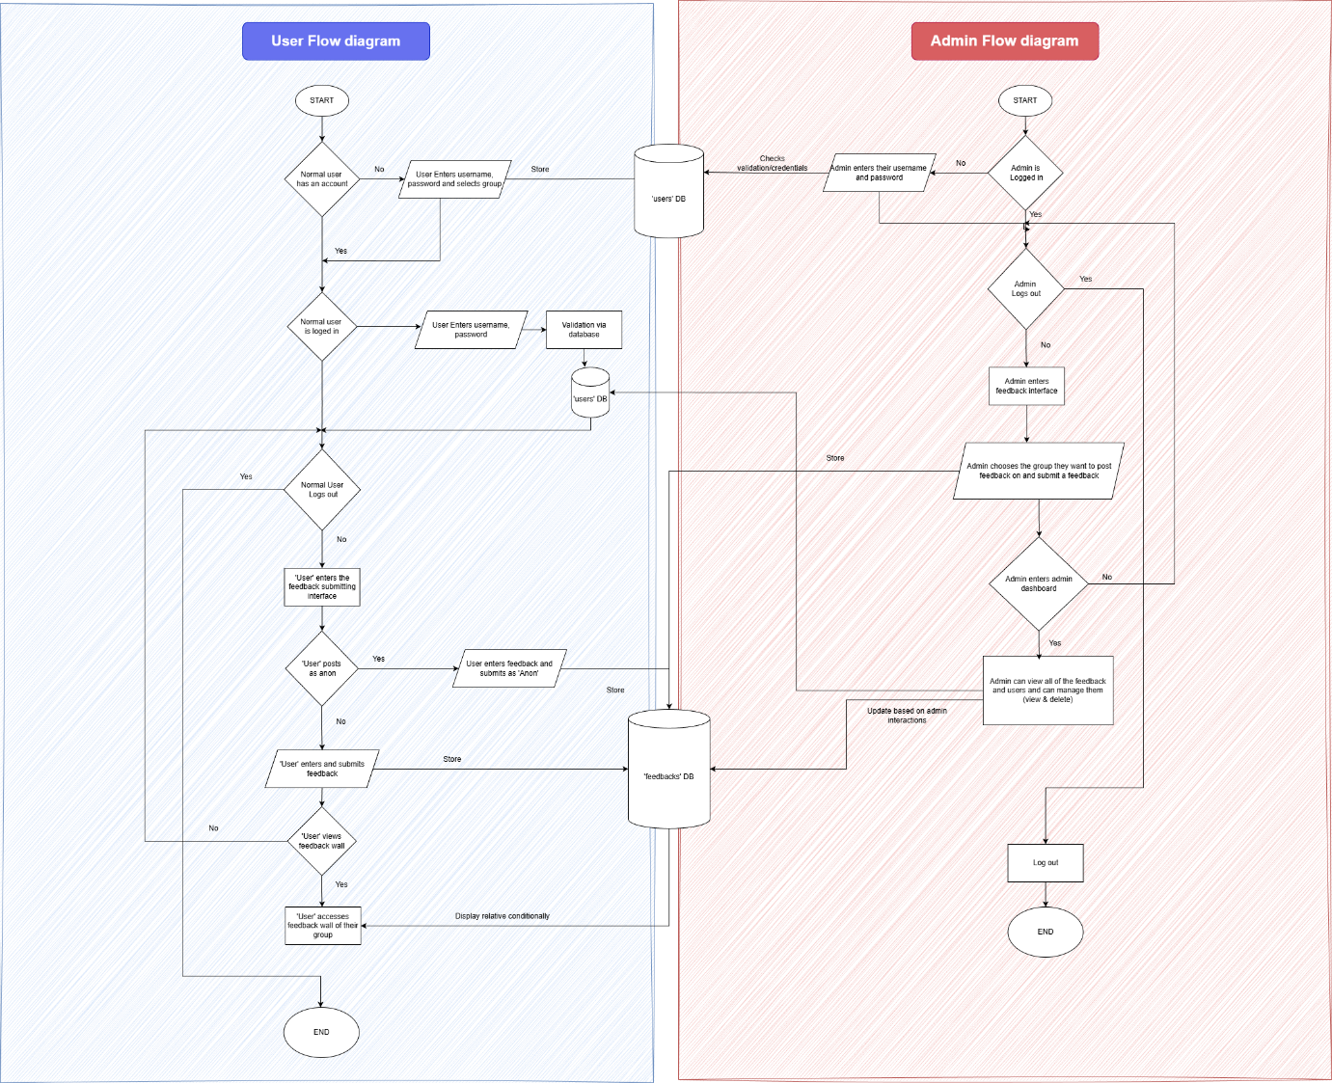

Fig 3.2 : Workflow diagram

Explanation: Normal users can create an account, log in, submit feedback (anon or named), and view feedback for their group. Admins log in using their own credentials, post feedback to groups, and access the admin dashboard. Inside the dashboard, admins can view all feedback, update or delete messages, and manage group visibility. Both user and admin interactions update a shared feedback database that stores all submissions.

### 3.3.4 ER Diagram

Fig 3.6: ER Diagram

Explanation: The system stores users, feedback, and groups, linking them through defined relationships. Each user can submit many feedback posts, and each post belongs to one user and one group. Groups organize feedback visibility, where multiple feedback entries appear within a single group. Attributes like username, role, message, display name, and timestamps describe each entity in detail.

### 3.3.5 Use Case Diagram

Fig 3.7 : Use case diagram

Explanation: This diagram shows how users interact with the Anonymous Feedback Wall system. Normal users can sign up, log in, write feedback, and view the feedback wall. Admins log in to manage feedback and manage users. Authentication is a required included process for all protected actions.

### 3.3.7 Sequence diagrams

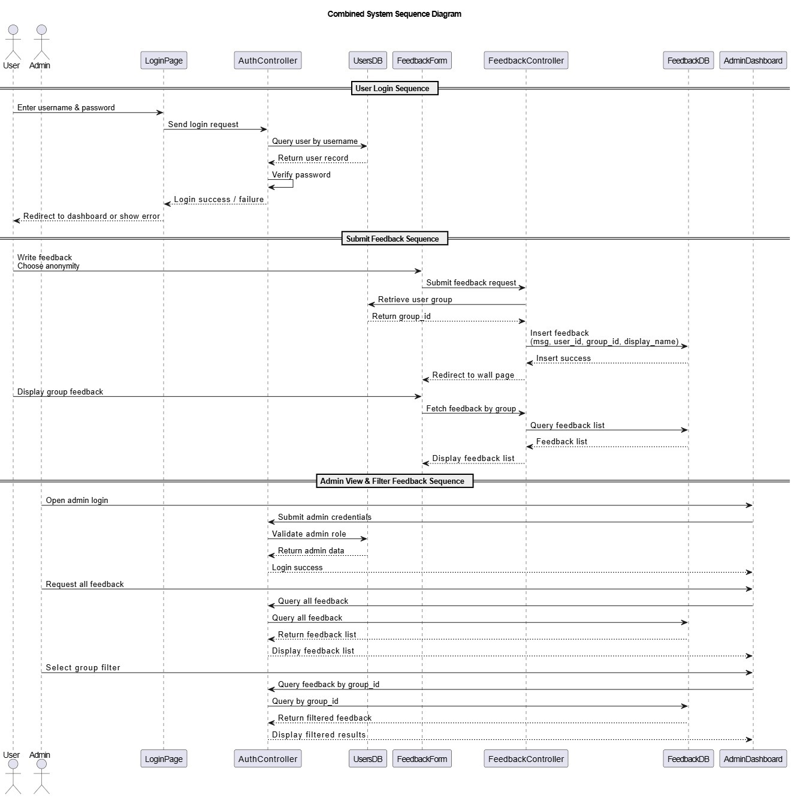

Explanation:

1 User Login Sequence: The User enters credentials on the LoginPage, which are validated by the AuthController against the UserDB to grant access.

2 Submit Feedback Sequence: A user submits feedback via the FeedbackForm; the FeedbackController processes this, retrieves group data, and saves the message to the FeedbackDB.

3 Admin View & Filter Feedback Sequence: An Admin logs in, and the system allows them to request all feedback or select a group filter to query and display feedback from the FeedbackDB via the AdminDashboard.

### References

* Shaheen, A., Azam, F., & Irshad, K. (2021, October). Anonymous Feedback: A real-time feedback to capture students’ engagement in learning process. In *International Conference on Medical Education (ICME 2021)* (pp. 65-68). Atlantis Press.
* Frampton, A., Fox, F., Hollowood, A., Northstone, K., Margelyte, R., Smith-Clarke, S., & Redwood, S. (2017). Using real-time, anonymous staff feedback to improve staff experience and engagement. *BMJ Quality Improvement Reports*, *6*(1).